Module 9 MVVM Navigation and Dialog Boundaries
Complete the dependency injection story by letting the container create both pages and both view models. The BOM view model asks an interface to edit an item or confirm deletion. The MAUI implementation handles navigation and the system alert. This makes the decision logic testable without opening a window.

Starting point and learning goals
Start from the completed Module 8 branch. Create a new feature branch before editing. Build the Windows target at each checkpoint.
Learning goals: Use constructor injection for a transient editor; Return a value from a UI workflow; Keep navigation and dialogs at the platform boundary; Use async generated commands; Keep the page focused on binding.

Step 1 Inject the editor view model
Concept. Use constructor injection for a transient editor
Do. Register ItemEditorViewModel and ItemEditorPage as transient services. Change the page constructor to accept the view model. Move edit prefilling into a LoadItem method that the page calls for an existing item.
Check. A new editor starts empty and Edit starts with the selected row values.

Step 2 Define interaction results
Concept. Return a value from a UI workflow
Do. Add IBomInteractionService with EditItemAsync and ConfirmDeleteAsync. A null edit result means Cancel or Back; a MaterialItem means Submit.
Check. The interface contains no ContentPage, Shell, or DisplayAlert calls.
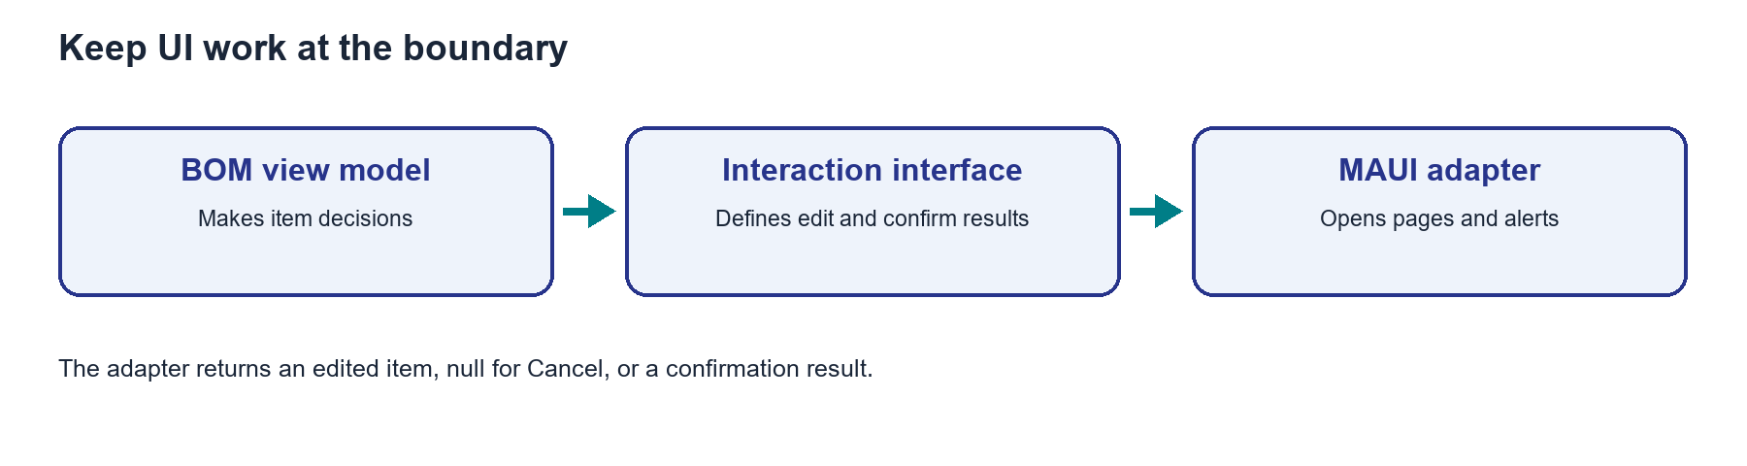
Figure. The view model asks for an edit or confirmation through an interface; the MAUI adapter opens pages and alerts.

Step 3 Implement the MAUI adapter
Concept. Keep navigation and dialogs at the platform boundary
Do. Add MauiBomInteractionService. Resolve a fresh editor page from DI, open it with Shell navigation, and await its result when it disappears. Use DisplayAlertAsync for delete confirmation. Unsubscribe the completion handler after use.
Check. The editor closes through Submit, Cancel, or Back without adding a row on cancellation.
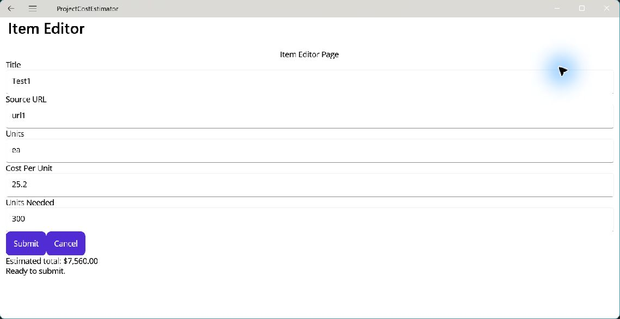
Figure. The injected editor opens with the selected item ready to edit.

Step 4 Move the BOM decisions
Concept. Use async generated commands
Do. Inject IBomInteractionService into BillOfMaterialsViewModel. AddAsync adds a returned item. EditAsync replaces only when a result is returned. DeleteAsync removes only after confirmation. The RelayCommand generator creates asynchronous command properties.
Check. Add, Edit, Cancel, and both deletion responses work.
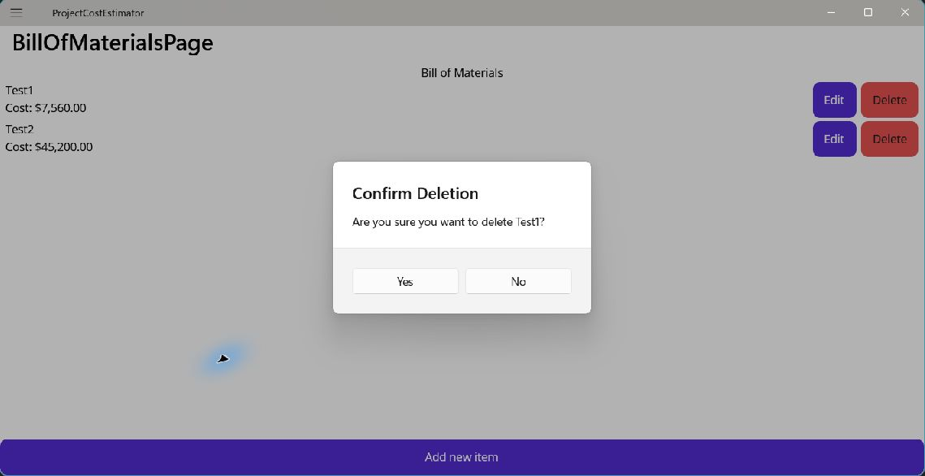
Figure. The interaction service owns the platform confirmation alert; the view model uses its result.

Step 5 Reduce page code
Concept. Keep the page focused on binding
Do. Remove BOM page event handlers. Its constructor only accepts the view model and sets BindingContext. Register the interaction implementation in MauiProgram.
Check. The page has no BOM data decisions; the view model has no MAUI page dependency.

Full source checkpoints
The files below show the completed module. Read them after following the small steps above, or use them to compare your result.

Services/IBomInteractionService.cs
using ProjectCostEstimator.Models;

namespace ProjectCostEstimator.Services;

// The view model asks for a result without depending on a MAUI page or dialog.
public interface IBomInteractionService
{
Task<MaterialItem?> EditItemAsync(MaterialItem? original);

Task<bool> ConfirmDeleteAsync(MaterialItem item);
}

Services/MauiBomInteractionService.cs
using Microsoft.Extensions.DependencyInjection;
using ProjectCostEstimator.Models;
using ProjectCostEstimator.Views;

namespace ProjectCostEstimator.Services;

public sealed class MauiBomInteractionService(IServiceProvider services) : IBomInteractionService
{
public async Task<MaterialItem?> EditItemAsync(MaterialItem? original)
{
var page = services.GetRequiredService<ItemEditorPage>();
page.LoadItem(original);

var completion = new TaskCompletionSource<MaterialItem?>(
TaskCreationOptions.RunContinuationsAsynchronously);
void OnDisappearing(object? sender, EventArgs args)
{
page.Disappearing -= OnDisappearing;
completion.TrySetResult(page.Item);
}

page.Disappearing += OnDisappearing;
try
{
await Shell.Current.Navigation.PushAsync(page);
return await completion.Task;
}
catch
{
page.Disappearing -= OnDisappearing;
throw;
}
}

public Task<bool> ConfirmDeleteAsync(MaterialItem item) =>
Shell.Current.DisplayAlertAsync(
"Confirm Deletion",
$"Are you sure you want to delete {item.Title}?",
"Yes", "No");
}

ViewModels/BillOfMaterialsViewModel.cs
using System.Collections.ObjectModel;
using CommunityToolkit.Mvvm.ComponentModel;
using CommunityToolkit.Mvvm.Input;
using ProjectCostEstimator.Models;
using ProjectCostEstimator.Services;

namespace ProjectCostEstimator.ViewModels;

public partial class BillOfMaterialsViewModel(
IBomService bomService,
IBomInteractionService interactions) : ObservableObject
{
public ObservableCollection<MaterialItem> Items => bomService.Items;

[RelayCommand]
private async Task AddAsync()
{
MaterialItem? item = await interactions.EditItemAsync(null);
if (item is not null)
bomService.AddItem(item);
}

[RelayCommand]
private async Task EditAsync(MaterialItem? original)
{
if (original is null || !Items.Contains(original))
return;

MaterialItem? edited = await interactions.EditItemAsync(original);
if (edited is not null)
bomService.ReplaceItem(original, edited);
}

[RelayCommand]
private async Task DeleteAsync(MaterialItem? item)
{
if (item is null || !Items.Contains(item))
return;

if (await interactions.ConfirmDeleteAsync(item))
bomService.RemoveItem(item);
}
}

ViewModels/ItemEditorViewModel.cs
using CommunityToolkit.Mvvm.ComponentModel;
using CommunityToolkit.Mvvm.Input;
using ProjectCostEstimator.Models;

namespace ProjectCostEstimator.ViewModels;

public partial class ItemEditorViewModel : ObservableObject
{
[ObservableProperty]
[NotifyCanExecuteChangedFor(nameof(SubmitCommand))]
public partial string Title { get; set; }

[ObservableProperty]
public partial string SourceUrl { get; set; }

[ObservableProperty]
[NotifyCanExecuteChangedFor(nameof(SubmitCommand))]
public partial string Units { get; set; }

[ObservableProperty]
[NotifyCanExecuteChangedFor(nameof(SubmitCommand))]
public partial string CostPerUnitText { get; set; }

[ObservableProperty]
[NotifyCanExecuteChangedFor(nameof(SubmitCommand))]
public partial string UnitsNeededText { get; set; }

[ObservableProperty]
public partial string TotalText { get; set; }

[ObservableProperty]
public partial string ValidationText { get; set; }

public event EventHandler<ItemSubmittedEventArgs>? Submitted;
public event EventHandler? CancelRequested;

public ItemEditorViewModel()
{
Title = string.Empty;
SourceUrl = string.Empty;
Units = string.Empty;
CostPerUnitText = string.Empty;
UnitsNeededText = string.Empty;
TotalText = "Enter cost and quantity to see a total.";
ValidationText = "Enter an item title and units.";

}

public void LoadItem(MaterialItem? item)
{
if (item is null)
return;

Title = item.Title;
SourceUrl = item.SourceUrl;
Units = item.Units;
CostPerUnitText = item.CostPerUnit.ToString();
UnitsNeededText = item.UnitsNeeded.ToString();
}

partial void OnTitleChanged(string value) => UpdateFormState();

partial void OnUnitsChanged(string value) => UpdateFormState();

partial void OnCostPerUnitTextChanged(string value)
{
UpdateTotalText();
UpdateFormState();
}

partial void OnUnitsNeededTextChanged(string value)
{
UpdateTotalText();
UpdateFormState();
}

private bool CanSubmit() => TryValidate(out _, out _, out _);

private bool TryValidate(out decimal cost, out decimal quantity, out string message)
{
cost = 0;
quantity = 0;

if (string.IsNullOrWhiteSpace(Title) || string.IsNullOrWhiteSpace(Units))
{
message = "Enter an item title and units.";
return false;
}

if (string.IsNullOrWhiteSpace(CostPerUnitText) ||
string.IsNullOrWhiteSpace(UnitsNeededText))
{
message = "Enter cost and quantity.";
return false;
}

if (!decimal.TryParse(CostPerUnitText, out cost) ||
!decimal.TryParse(UnitsNeededText, out quantity) ||
cost < 0 || quantity < 0)
{
message = "Enter nonnegative numbers for cost and quantity.";
return false;
}

try
{
_ = cost * quantity;
}
catch (OverflowException)
{
message = "Numbers are too large to calculate a total.";
return false;
}

message = "Ready to submit.";
return true;
}

private void UpdateFormState()
{
TryValidate(out _, out _, out string message);
ValidationText = message;
}

[RelayCommand(CanExecute = nameof(CanSubmit))]
private void Submit()
{
if (!TryValidate(out decimal cost, out decimal quantity, out string message))
{
ValidationText = message;
return;
}

MaterialItem item = new(
Title.Trim(),
SourceUrl.Trim(),
Units.Trim(),
cost,
quantity);

Submitted?.Invoke(this, new ItemSubmittedEventArgs(item));
}

[RelayCommand]
private void Cancel() => CancelRequested?.Invoke(this, EventArgs.Empty);

private void UpdateTotalText()
{
if (string.IsNullOrWhiteSpace(CostPerUnitText) ||
string.IsNullOrWhiteSpace(UnitsNeededText))
{
TotalText = "Enter cost and quantity to see a total.";
return;
}

if (!decimal.TryParse(CostPerUnitText, out decimal cost) ||
!decimal.TryParse(UnitsNeededText, out decimal quantity) ||
cost < 0 || quantity < 0)
{
TotalText = "Enter nonnegative numbers for cost and quantity.";
return;
}

try
{
TotalText = $"Estimated total: {cost * quantity:C}";
}
catch (OverflowException)
{
TotalText = "Numbers are too large to calculate a total.";
}
}
}

Views/ItemEditorPage.xaml.cs
using ProjectCostEstimator.Models;
using ProjectCostEstimator.ViewModels;

namespace ProjectCostEstimator.Views;

public partial class ItemEditorPage : ContentPage
{
private readonly ItemEditorViewModel viewModel;

public MaterialItem? Item { get; private set; } = null;

public ItemEditorPage(ItemEditorViewModel viewModel)
{
InitializeComponent();
this.viewModel = viewModel;
viewModel.Submitted += OnSubmitted;
viewModel.CancelRequested += OnCancelRequested;
BindingContext = viewModel;
}

public void LoadItem(MaterialItem? item) => viewModel.LoadItem(item);

private async void OnSubmitted(object? sender, ItemSubmittedEventArgs e)
{
Item = e.Item;
await Navigation.PopAsync();
}

private async void OnCancelRequested(object? sender, EventArgs e)
{
await Navigation.PopAsync();
}
}

Views/BillOfMaterialsPage.xaml.cs
using ProjectCostEstimator.ViewModels;

namespace ProjectCostEstimator.Views;

public partial class BillOfMaterialsPage : ContentPage
{
public BillOfMaterialsPage(BillOfMaterialsViewModel viewModel)
{
InitializeComponent();
BindingContext = viewModel;
}
}

MauiProgram.cs
using Microsoft.Extensions.Logging;
using ProjectCostEstimator.Services;
using ProjectCostEstimator.ViewModels;
using ProjectCostEstimator.Views;

namespace ProjectCostEstimator
{
public static class MauiProgram
{
public static MauiApp CreateMauiApp()
{
var builder = MauiApp.CreateBuilder();
builder
.UseMauiApp<App>()
.ConfigureFonts(fonts =>
{
fonts.AddFont("OpenSans-Regular.ttf", "OpenSansRegular");
fonts.AddFont("OpenSans-Semibold.ttf", "OpenSansSemibold");
});

#if DEBUG
builder.Logging.AddDebug();
#endif

builder.Services.AddSingleton<IBomService, InMemoryBomService>();
builder.Services.AddSingleton<IBomInteractionService, MauiBomInteractionService>();
builder.Services.AddTransient<BillOfMaterialsViewModel>();
builder.Services.AddTransient<BillOfMaterialsPage>();
builder.Services.AddTransient<ItemEditorViewModel>();
builder.Services.AddTransient<ItemEditorPage>();

return builder.Build();
}
}
}

Further reading
https://learn.microsoft.com/dotnet/maui/fundamentals/dependency-injection/
https://learn.microsoft.com/dotnet/communitytoolkit/mvvm/generators/relaycommand

